|  |
| --- |
| Hire-A-Chef |
| High Level Requirements Document |
| **Version 1.0** |
| **Date 2024.10.02** |

**Project Identification**

|  |  |
| --- | --- |
| **Project:** | Hire-A-Chef App |
| **Prepared By:** | Team 34 |
| **Document Version:** | 1.0 |
| **Published Date:** | 2024-10-02 |

**Contributors**

The following individuals contributed to this document.

| **Name** | **Title** |
| --- | --- |
| Nithiyan Annapoorani Valluvan, Basil Shaji, Gokul Jinu | *Project Vision Document* |
| Ans Joju, Nithiyan Annapoorani Valluvan | *High-Level Business Requirements* |
| Ans Joju | *Project Summary* |
| Basil Shaji | *Minutes of Meeting* |
|  |  |

**Distribution**

This document is distributed to all the following people.

| **Name** | **Title** |
| --- | --- |
| Nithiyan Annapoorani Valluvan | Team Member |
| Ans Joju | Team Member |
| Basil Shaji | Team Member |
| Gokul Jinu | Team Member |
| Anjana Shah | Project Coordinator |

**Referenced Documents**

This document refers to the following materials

|  |  |  |  |  |
| --- | --- | --- | --- | --- |
| **Version number** | **Title** | **Author** | **Date** | **Source / Location** |
| 1.0 | *Project Summary* | Ans Joju | 17th September,2024 | [F24-T34-Project-Summary-Template](https://georgebrowncollege-my.sharepoint.com/personal/101418712_georgebrown_ca/Documents/F24-T34-Project-Summary-Template.docx?web=1) |
| 1.0 | *Project Vision* | Nithiyan Annapoorani Valluavan, Basil Shaji, Gokul Jinu | 2nd October,2024 | [F24-T34-Project Vision](https://georgebrowncollege-my.sharepoint.com/personal/101418712_georgebrown_ca/Documents/F24-T34-Project%20Vision.docx?web=1) |
| *1.0* | *Minutes of Meeting* | *Basil Shaji* | *2nd October,2024* | [F24-T34-Minutes of Meeting-Template](https://georgebrowncollege-my.sharepoint.com/personal/101418712_georgebrown_ca/Documents/F24-T34-Minutes%20of%20Meeting-Template.docx?web=1) |
| *1.0* | *User Stories & Persona’s* | *Nithiyan Annapoorani Valluvan* | *2nd*  *October,2024* | [F24-T34-Persona-User Stories](https://georgebrowncollege-my.sharepoint.com/personal/101418712_georgebrown_ca/Documents/F24-T34-Persona-User%20Stories.docx?web=1) |

**Revision History**

|  |  |  |  |
| --- | --- | --- | --- |
| **Version Number** | **Revision Date** | **Summary of Changes** | **Modified by** |
| 0.1 | *28th Sept, 2024* | Initial Draft | Ans Joju |
| 1.0 | *2nd Oct, 2024* | Tables, Diagrams, Scope | Nithiyan Annapoorani Valluvan |

[Note: It is recommended that drafts be numbered 0.1 to 0.9, and that the first approved version be numbered 1.0. Thereafter, new version numbers will depend upon changes: 1.01, 1.1, etc for minor updates, 2.0, 3.0 etc for major changes.]

TABLE OF CONTENTS

1. Business Context Diagram Error! Bookmark not defined.

2. REquirements Scope Statements 5

3. High Level Business Requirements Sign-Off 6

1. Business Context Diagram

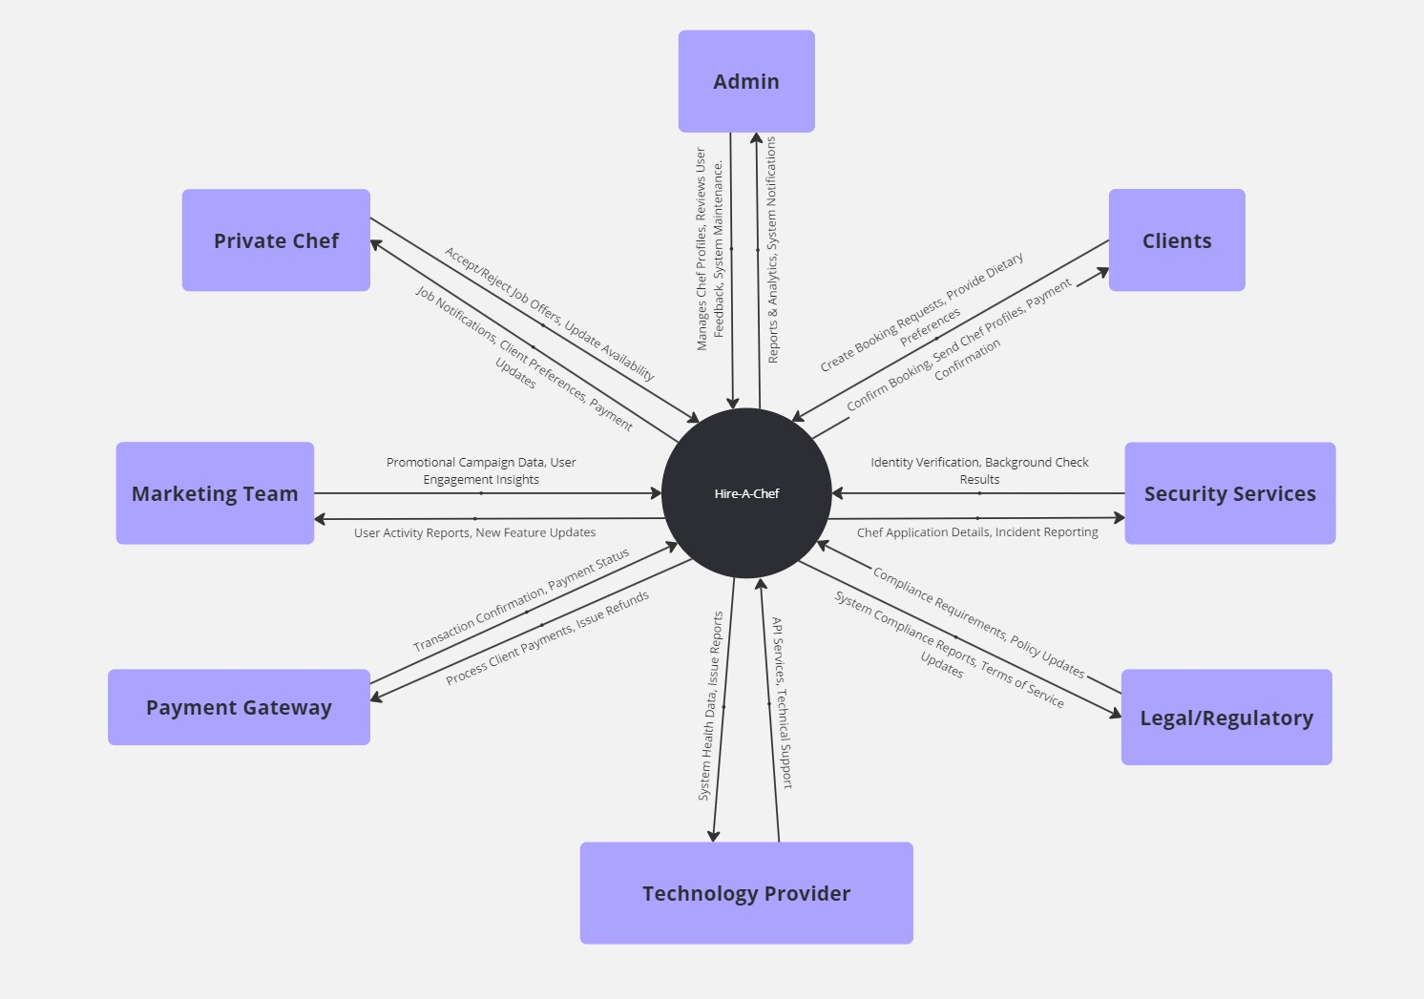

### Requirement Scope Area

|  |  |
| --- | --- |
| **Requirement Scope Area** | **Description** |
| |  | | --- | | **Booking Management** | |  | | |  | | --- | | Handles client bookings, chef assignments, and availability updates. This area manages the core functionality of connecting clients to private chefs based on requirements. | |  | |
| |  | | --- | | **User Authentication** | |  | | |  | | --- | | Manages secure user sign-ups, logins, and profile management. Ensures that all users are verified and have the right access permissions. | |  | |
| |  | | --- | | **Payment Processing** | |  | | |  | | --- | | Integrates with a payment gateway to handle client payments, chef payouts, and refunds. Ensures secure financial transactions. | |  | |
| |  | | --- | | **Feedback & Ratings** | |  | | |  | | --- | | Collects and stores feedback from clients and chefs. Enables clients to rate chefs based on their service quality. | |  | |
| |  | | --- | | **Compliance Management** | |  | | Ensures that all chefs meet legal requirements (e.g., food handling certification). Manages background checks and identity verification. |

### External Entity

|  |  |
| --- | --- |
| **External Entity** | **Description** |
| |  | | --- | | **Clients** | |  | | |  | | --- | | Users who book private chefs through the platform. They initiate booking requests and provide dietary and event preferences. | |  | |
| |  | | --- | | **Private Chefs** | |  | | |  | | --- | | Service providers who receive job offers based on client preferences and update their availability. | |  | |
| |  | | --- | | **Admin** | |  | | |  | | --- | | System administrators who oversee platform management, chef profile maintenance, and resolve escalations. | |  | |
| |  | | --- | | **Payment Gateway** | |  | | |  | | --- | | External financial service provider is responsible for processing payments and refunds. | |  | |
| |  | | --- | | **Security Services** | |  | | |  | | --- | | Third-party service that performs background checks and identity verification for chefs. | |  | |
| |  | | --- | | **Marketing Team** | |  | | |  | | --- | | Internal team that handles promotions, user engagement, and product branding strategies. | |  | |
| |  | | --- | | **Legal/Regulatory** | |  | | |  | | --- | | Governing bodies that set compliance standards for food safety, customer data protection, and operational guidelines. | |  | |
| |  | | --- | | **Technology Provider** | |  | | External service providers for server hosting, API services, and technical support. |

### Information Flows

| **Information Flows** | **Description** |
| --- | --- |
| |  | | --- | | **Booking Request** | |  | | |  | | --- | | Clients send booking requests containing event details, dietary preferences, and budget to the system. | |  | |
| **Job Offers** | |  | | --- | | System sends job offers to chefs based on client requirements and chef availability. | |  | |
| |  | | --- | | **Booking Confirmation** | |  | | |  | | --- | | System notifies clients of confirmed bookings and sends chef details. | |  | |
| |  | | --- | | **Payment Confirmation** | |  | | |  | | --- | | Payment Gateway sends confirmation of successful payment transactions. | |  | |
| |  | | --- | | **Background Check Report** | |  | | |  | | --- | | Security Services send background verification results for chefs. | |  | |
| |  | | --- | | **Client Feedback** | |  | | |  | | --- | | Clients submit feedback and ratings after service completion, stored for future references. | |  | |
| |  | | --- | | **Compliance Report** | |  | | |  | | --- | | Legal/Regulatory entities send compliance status reports for chefs (e.g., certifications). | |  | |
| |  | | --- | | **API Response Data** | |  | | |  | | --- | | Technology Provider sends API data for system health and operational support. | |  | |
| |  | | --- | | **Incident Reports** | |  | | System shares incident reports with Security Services for review and action. |

1. Requirements Scope Statements

|  |  |  |
| --- | --- | --- |
| **HLR#** | **Description** | **Priority**  **(H, M, L)** |
|  | |  | | --- | | The system should allow clients to search for chefs based on location, budget, and dietary preferences. | |  | | H |
|  | |  | | --- | | The system should enable private chefs to update their availability and receive notifications when a new job request matches their criteria. | |  | | H |
|  | |  | | --- | | Secure user authentication should be implemented for clients, chefs, and administrators, ensuring role-based access permissions. | |  | | H |
| |  | | --- | |  | | HLR04 | | |  | | --- | | Payment processing should be integrated with a third-party gateway to handle secure transactions and refunds. | |  | | H |
| |  | | --- | | HLR05 | | |  | | --- | | The system should track and store client feedback and ratings for each completed service. | |  | | |  | | --- | | M | |  | |
| HLR06 | |  | | --- | | The admin should have the ability to add, update, or remove chefs and resolve booking issues manually. | |  | | |  | | --- | | H | |  | |
| HLR07 | |  | | --- | | The system should generate a summary report for each booking, including chef details, client requirements, and payment status. | |  | | M |
| HLR08 | |  | | --- | | Compliance management should be integrated to verify chef certifications and identity information, updating status in real-time. | |  | | |  | | --- | | M | |  | |
| HLR09 | |  | | --- | | Marketing team access should be limited to viewing non-sensitive data for creating promotions and monitoring user engagement. | |  | | |  | | --- | | L | |  | |
| HLR10 | |  | | --- | | Security services should be able to receive and act on incident reports and provide compliance updates to the platform. | |  | | |  | | --- | | L | |  | |
| HLR11 | |  | | --- | | The system should maintain high availability, with uptime monitored and supported by a dedicated technology provider. | |  | | H |

1. High Level Business Requirements Sign-Off

The undersigned acknowledge their agreement with the contents of Version 1.0 of the High-Level Requirements document for Hire-A-Chef.

Following approval of this document, requirements changes will be governed by the project’s change management process, including impact analysis and appropriate reviews and approvals, under the general control of the Project Plan and according to company policy. Approved Change Request Documents, if present, will be attached to this Requirements Document as updates.

|  |  |  |
| --- | --- | --- |
| **Name** | **Project Role and**  **Functional Area** | **Date Signed** |
| Nithiyan Annapoorani Valluvan | Quality Assurance Lead, | 2nd October, 2024 |
| Ans Joju | Group Coordinator, Backend Developer | 2nd October, 2024 |
| Basil Shaji | UI/UX Designer | 2nd October, 2024 |
| Gokul Jinu | Lead Developer | 2nd October, 2024 |

* Note: physical signatures are not required. Email approvals are acceptable and should be appended to project documents.